

***Term Project***

**ATTENDANCE SYSTEM USING RADIO FREQUENCY IDENTIFICATION DEVICE (RFID)**

***By*** *Teja Vamsi Bokkasam*

*bokkasam.t@northeastern.edu*

EMGT5220: Engineering Project Management, Fall 2021

Northeastern University

Instructor: Prof. George Kontopidis

Table of Contents

1. Purpose 3

2. Objective 3

3. Scope 3

4. Funder/Investor 3

5. Critical Success Factors 3

6. Assumptions 4

7. Technical Approach 4

8. Organization 4

9. Project Plan 5

a. Work Breakdown Structure (WBS) 5

b. Resource Plan and Responsibilities (RACI) 6

c. Financial Plan 7

d. PERT Chart 8

e. Gantt Chart 9

f. Resource Allocation 9

10. Risk Assessment (SWOT, FMEA, RPN) 10

11. Monitoring and Control 13

12. Summary 14

13. Appendix 14

A) MindMap 14

B) Flow chart 15

C) State Diagram 16

14. Future Scope 17

15. References 17

## Purpose

In the contemporary world, with enormous academic institutes all around the place it might be a major issue to deal with a lot of understudies specially to get the participation. Currently, procedure for obtaining participation in dominant part colleges despite all the manual procedure used which implies that the instructor will give a bit of participation paper or will be asked to sign in on their respective portal, at the point when starting the class / address and the understudies will check and do likewise. To reduce the quality time wasted during the participation check-in process and improve its efficiency during the academic or address hours RFID frame used to capture alternate participation naturally. This venture will be utilized understudy ID card as Radio frequency tag and a RFID per user. This RFID framework could be incorporated with programming. This technique is increasingly coercive to prevent issue in process getting participation physically.

## Objective

This project a physical prototype card reader which aims to use the technology and reduce the errors in taking the attendance and maintain a uniform evaluation on everyone progressively .It also assists to reduce complexity of manual attendance sheet and to enable RFID applications in our day to day lives. This automation process of taking the participation also helps avoid malpractices and to prolongation smart way of using attendance systems. With this system we can also study various technologies related to the GSM and Arduino modules and implement them in attendance systems to reduce the usage of skilled labor and implement computerized output systems. The recipient would be any organization or industry which records the understudy participation .

## Scope

The scope of the project is the develop the economic RFID based attendance system using components like Arduino Uno , RFID scanner tags along with a GSM module to reduce the time taken for taking the attendance and make it more efficient while maintaining a uniform evaluation on every individual progressively. The micro-controller controls main part of the system, whose main objective of the system is to uniquely identify the attendance for an individual person and evaluate following. We will be using RFID tags for reading and storing unique ID number and attendance. A mobile or PC or an internal memory chip can be used to store all the details of attendance made.

## Funder/Investor

This project will be funded by any organization or institutes who must keep the participation record of individuals working in it or we can evolve a new company from the product here their benefit will be mostly in the long term as it will be built from scratch. A safer approach would be to introduce it to the universities around , to implement better attendance system. The major stake holders for this digitized attendance system are :

- Northeastern University , Boston.

- Sanghamitra School , Hyderabad.

- Silver Oaks International , Mumbai.

- Rotary Constructions Pvt Ltd , Singapore.

## Critical Success Factors

Several elements influence the outcome of any project. These may not necessarily ruin a project, but they might cause a significant change in scope or a significant setback. As a result, it's critical to determine what the project depends on the most for its effective execution and completion. The following are the most critical factors for this project :

* Careful examinations of the classrooms and institutional areas are required for measurements of the scanners to be installed
* Because this project involves extensive testing at several points during the project, it is vital to automate the procedure for various degrees of testing.
* Comprehensive training for students is required for understanding the RFID progression for attendance.
* Regular funding from stakeholders should be ensured for smooth assembly of the RFID scanner and project implementation.
* The management and development teams must work closely together, which is critical because this project mandates a high level of inter-dependency between management, installation, and development teams.

## Assumptions

The following assumptions are made for this project :

* The equipment will be provided by Moin Sul electricals in a timely manner.
* Intricate testing plans can be systematized for repetitive determinations to ensure the quality of

the prototype

* All the institutional geographical features are understood for installing the scanners.
* The project team uses previously stored data on sheets to enter the student ID and details onto the database.

## Technical Approach

The proposed project will work in a Arduino Uno can run the framework quiet time-frame and running at 1024 x 768 or higher-resolution display. The program will be written in C++, and we will develop it in the Arduino IDE. Arduino Integrated Development Environment (IDE)is generally a collaboration application for any operation system like windows , mac or Linux that is recorded in functions from C languages. ‘Sketch’ is a known program code composed in Arduino. The oscillations in the Piezo signal are between 2 – 4 kHz. A 16×2 LCD has two registers like information register and order register .The DS1307/1308 works as a slave gadget on the sequential transport.

## Organization

This project follows flat organizational structure to manage and organize the project components. As we only have one in middle management between the project manager and the other functional managers.The primary responsibility of the project manager is to coordinate the activity of numerous departments. To ensure the project's success, all departments will work together. A flat organizational structure promotes important communication strategies and more responsibilities over the employee to create error free attendance prototype and this type of organization enables faster decision-making to deliver clients requirements rapidly.

Figure 1 Org Chart

## Project Plan

### Work Breakdown Structure (WBS)

Below Table 1 shows the Work breakdown structure for this project. The work breakdown structure (WBS) is a hierarchical breakdown of work to be executed on a project into Tasks and subtasks. In addition to the tasks, the time it will take to execute such tasks, and the corresponding resources to be utilized are also indicated. This process is replicated in the Figure below:

|  |  |  |  |  |  |  |
| --- | --- | --- | --- | --- | --- | --- |
| **ID** | **TASK** | **TIME**  **(in days)** | **DEPENDENCY** | **RESPONSIBILITY** | DIFFICULTY | FAMILIARITY |
| 1 | Design Development Plan | 6 | - | Development Manager | 1 | 1 |
| 1.a | Arduino Uno setup | 5 | - | Design Manager | 1 | 1 |
| 1.b | Purchasing RFID components | 5 | - | Electronic Engineer | 1 | 1 |
| 1.c | Electing clock and display type | 4 | 1a , 1b | Electronic Engineer | 2 | 1 |
| 2 | Developing the Prototype | 21 | 1 | Operations Manager | 3 | 2 |
| 2.a | Assembling the scanner | 11 | 1.c , 2 | Application Engineer | 1 | 2 |
| 2.b | Real time clock operation | 5 | 1.c | Application Engineer | 1 | 3 |
| 2.c | LED indication and  Buzzer installment | 11 | 2.a | Electrical Engineer | 1 | 1 |
| 3 | Software Design algorithm | 28 | 2.b , 2.a | Software Engineer | 2 | 2 |
| 3.a | SMS system in GSM module | 13 | 2c | GSM specialist | 3 | 3 |
| 3.b | Labeling and Customization's | 7 | 3 , 3a | Testing Manager | 1 | 1 |

Table 1 Work Breakdown Structure

### Resource Plan and Responsibilities (RACI)

The Table-2 below represents the relationship between the WBS activities and the different members that are involved in the projects. The involvement of everyone in each of the subtasks is identified in terms of responsibility (R), accountability (A), consultation (C), and being informed (I).

|  |  |  |  |  |
| --- | --- | --- | --- | --- |
|  | **WBS** | **RESPONSIBLITY** |  |  |
|  |  | **Project Manager** | **Development Team** | **Installation Team** |
| 1 | Design Development Plan | R |  |  |
| 1.a | Purchasing Arduino Uno |  | R | I |
| 1.b | Purchasing RFID components |  | R | C |
| 1.c | Selecting Clock and display |  | A | R |
| 2 | Developing the Prototype | A | R | C |
| 2.a | Assembling the scanner |  | R |  |
| 2.b | Real time clock operation |  | R |  |
| 2.c | LED indication and  Buzzer installment |  | A | R |
| 3 | Software Design algorithm | A | R |  |
| 3.a | SMS system in GSM module | A | R | C |
| 3.b | Labeling and Customization's | R | A |  |

Table 2 RACI Table

### Financial Plan

The Financial Plan of the project consists of monthly budget based on the flow of tasks. In the figure below, we have the budget split by every month. Hence, the monthly costs can be calculated by summing up the cost estimates for every month. The projected budget for this project with a duration of 5 months is roughly about $29,500 and is shown in the table 2 below .

|  |  |  |  |  |  |  |
| --- | --- | --- | --- | --- | --- | --- |
| MONTHLY BUDGET FOR RFID PROJECT | | | | | | |
| WORK ID | ESTIMATE | 1 | 2 | 3 | 4 | 5 |
| 1 | $1,500 | $1,500 |  |  |  |  |
| 1.a | $5,000 | $5,000 |  |  |  |  |
| 1.b | $6,000 | $6,000 |  |  |  |  |
| 1.c | $5,000 | $2,700 | $2,300 |  |  |  |
| 2 | $1,000 |  | $1,000 |  |  |  |
| 2.a | $1,100 |  | $1,100 |  |  |  |
| 2.b | $700 |  |  | $700 |  |  |
| 2.c | $2,500 |  | $2,000 | $500 |  |  |
| 3 | $2,700 |  | $1,000 | $1,000 | $700 |  |
| 3.a | $1,900 |  |  |  | $1,900 |  |
| 3.b | $2,100 |  |  |  |  | $2,100 |
| TOTAL | $29,500 | $15,200 | $7,400 | $2,200 | $2,600 | $2,100 |

Table 3 Financial Plan (Monthly) of the project

### PERT Chart

The PERT Chart (given in Figure 3) aids in the organization ,mapping and coordination of the tasks required for this project. It shows us how tasks are divided down into several distinct tasks and how the project schedule's timetable is visualized.

**LEGEND**

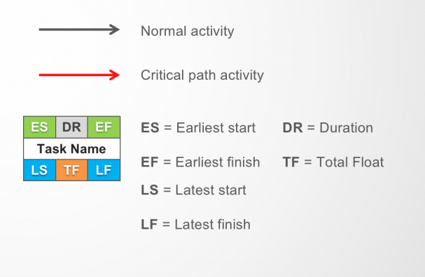

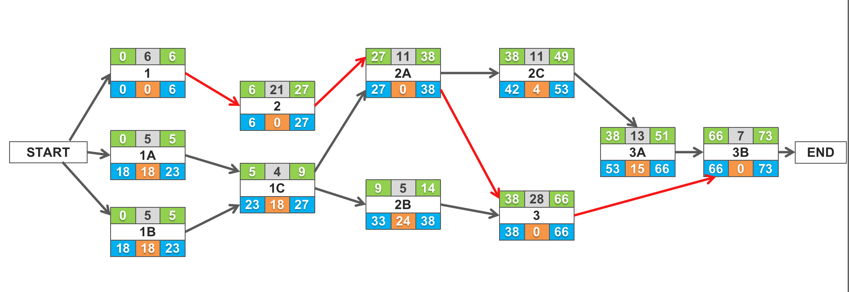

Figure 2 PERT Chart with ES , EF , LS , LF and Critical path

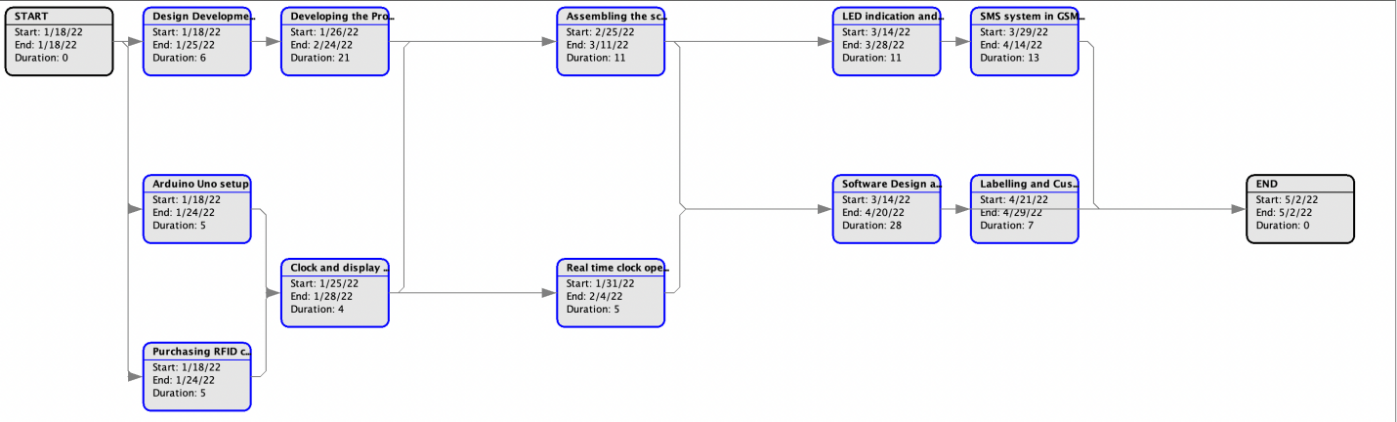

Figure 3 PERT chart of the project.

### Gantt Chart

More than a century after its invention, the Gantt chart is still a powerful tool utilized by project managers in practically every sector. The Gantt Chart depicts a general timeline for the project's completion. This charts most important characteristics are to shows us the durations of each task performed during the project's timeline along with the two keys milestones, the start and end. The digitalization of the attendance system will take approximately 15 weeks, with key deliverables at the end of each of the main activities, as shown in the WBS. The following is the Gantt chart for this project:

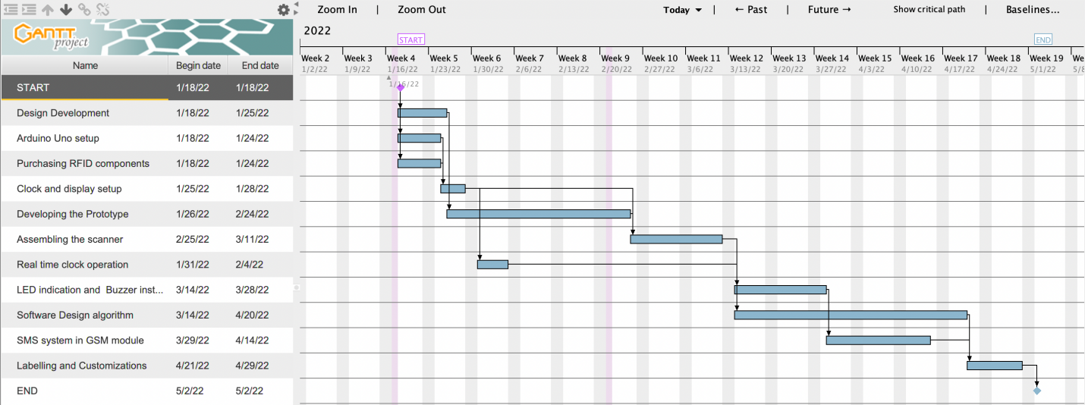

Figure 4 Gantt Chart of the Project created using GanttProject.exe

### Resource Allocation

Projects require careful resource allocation. It shows the amount of work that has to be completed for the project and assigns responsibility for each job to a team member . When team members are overloaded as a result of multitasking, it provides a visual depiction for administration to balance resources. The resource allocation chart for this project may be seen below.

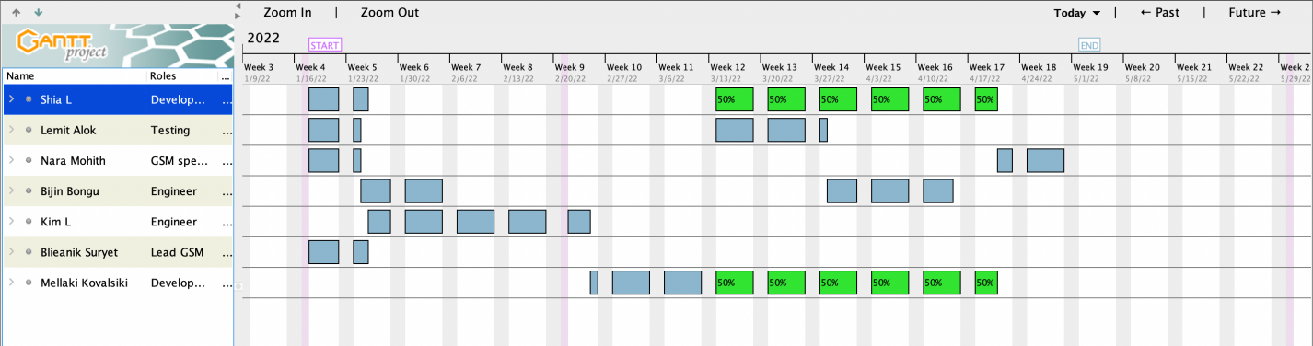

Figure 5 Resource Allocation

## Risk Assessment (SWOT, FMEA, RPN)

One of the most critical responsibilities of the PM is risk assessment. Recognizing where the project might go wrong ahead of time can aid in the design and deployment of remedies to ensure that the project is not harmed. The identification of risks should come first, followed by qualitative and quantitative studies (Jack R. Meredith, 1999). A basic tool used in Lean Manufacturing called the Fishbone or Ishikawa Diagram may be used to detect vulnerabilities. The method is used in lean manufacturing to find root causes by brainstorming reasons in six different areas. In our scenario as seen in the figure a ,these typical categories may be altered, and the fishbone diagram can be utilized to indicate possible project delays.

Equipment

Testing

Workforce

Meagerness Trail data analysis delay Breakdown

Conflicts Structural defects found Availability

PROJECT DELAYS

Rise in student strength Lack of planning Lack in quality

Accidents Scheduling errors GSM module connectivity

Materials

Management

Environment

Figure 6 Fish bone diagram

**a) SWOT ANALYSIS**

The SWOT Analysis examines the project's core four aspects: strengths, weaknesses, opportunities, and threats. This allows us to plan and manage risks strategically based on the scenario.

Figure 7 SWOT ANALYSIS

**b) FMEA**

The FMEA table is a quantitative risk assessment tool for examining risks that have been identified. The severity, impact, and inability to recognize risk are among the indicators examined here. The cumulative weight of these metrics is known as the Risk Priority Number (RPN). The RPN is a signal for high-impact threats that must be taken seriously.

The planned approach to these hazards is also highlighted in the table below. Each element is evaluated on a scale of 1 to 3 and the RPN is estimated as a product of the three attributes.

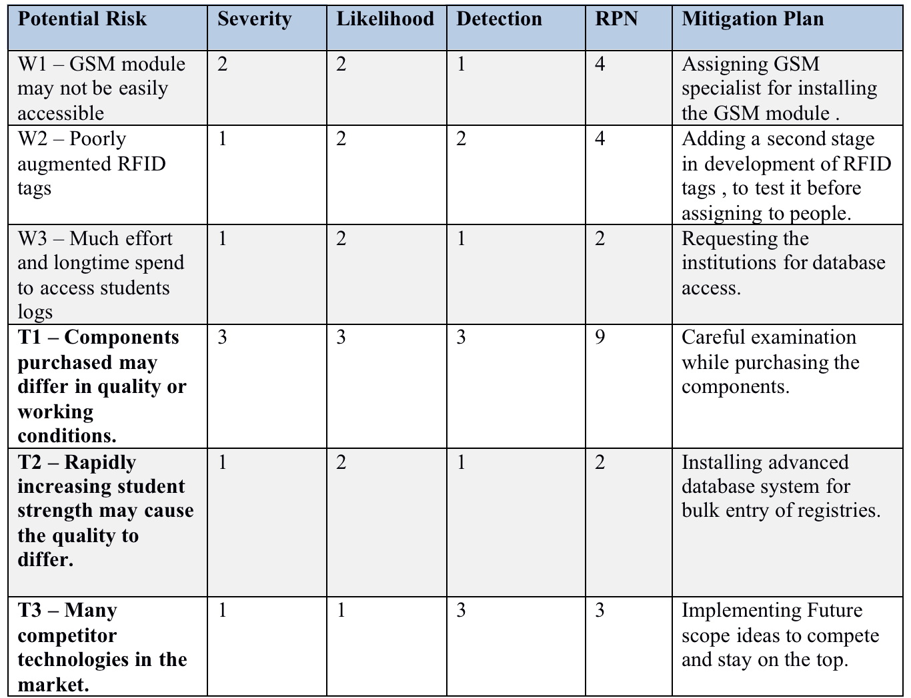

Figure 8 FMEA table

**C) RPN**

Each threat and weakness are grouped into their appropriate sections in the matrix based on the RPN we determined in the previous step. The most critical danger to be aware of is depicted in the red section of the diagram beneath. The effect of the risk if it occurs is shown by the horizontal axis, while the likelihood of meeting the risk is represented by the vertical axis as shown in figure 6. For greater comprehension in the figure, the risk labels are represented in the diagram.

|  |  |  |
| --- | --- | --- |
| T3 |  | T1 |
| W3 | W1 , W2 |  |
|  | T2 |  |

3

Probability 2

1

1 2 3

Impact

Figure 9 FMEA table

## Monitoring and Control

The monitoring and controlling systems used in this project will assist keep the project on track by regulating the scope, time, and cost of the project. The project manager will be in charge of the whole project and will ensure that all information is up to date. Furthermore, the project will be having three functional managers each for Development Department , Operations Department and Testing Department who will be responsible for tracking progress within their respective teams.

|  |  |  |
| --- | --- | --- |
| **MONITORING / CONTROL** | **FREQUENCY** | **RESPONSIBILITY** |
| Status and Budget Monitoring | Once per 3 weeks | Project Manager |
| Software Algorithm Report | 3 meets with 1 week gap between.  (Before the task 3) | Technical Lead |
| GSM monitoring and enhancement | Once (Before the task 3.a) | GSM specialist |
| Labeling and Client Customization Meet | Once ( After the task 3.a) | Testing Manager |

Table 4 Monitoring and Control table

The scope and budget of a project may change during its implementation or the schedule may slip. As a result, it's critical to control the project at regular intervals during its life cycle to verify that the objectives are completed.

We can keep track of how the RFID components purchased are being installed without wastage , the financial resources being allocated to different departments without excess allotment , growth of the working staff , engineers and managers.

## Summary

In summary this project ‘Attendance system using Radio Frequency Identification Device (RFID)’ helps academic institutes , organizations or industries to change their traditional way of taking attendance system. Attendance Systems were designed long before mobile devices were brought to the market, thus it takes an hour to take attendance using a variety of technologies, making it smart.  So  RFID Readers and Bluetooth/infrared are being employed in the traditional model of attendance system, to render the  complex, and error prone method of replacing the pen and paper way of taking attendance. With the advent of GPS-based systems, a smart method of attendance may be implemented. In this project, we described the components utilized, how each component functions independently, and why a given component of a specific kind was chosen to do its specific function in order to fulfill the mission.

The project will be completed over the course of 14 weeks. It follows a flat organization ,with a team of 10 people costing $29,500 over the course time. Major educational institutes will be sponsoring the project to inculcate the modern digital attendance system.

## Appendix

### MindMap

The mind map shown in Figure 2 proves to be very useful when it can be difficult to think of all the different aspects of this project. This brainstorming technique builds around a central idea and grows as a network of neurons to capture all the possible aspects of the central idea in question. This mind map drives much of the implementation plan for this project.

Figure 10 Mind map for Project

### Flow chart

In the improvement pattern of the framework, choices were made on the pieces of the framework to be figured it out in the equipment structure and the parts to be executed in programming. The product is disintegrated into modules with the goal that every module can be exclusively tried as a unit and repaired before the modules are coordinated and tried as a programming framework to guarantee that the product configuration meets its determination. The program will be written in C++, and we will develop it in the Arduino IDE. The Arduino Integrated Development Environment (IDE) is a cross-platform application (for Windows, macOS, Linux) that is written in functions from C and C++. It is used to write and upload programs to Arduino compatible boards, but also, with the help of 3rd party cores, other vendor development boards.

For the development of the software, we require mainly an algorithm. The algorithm we use here is shown by the flowchart below :

Figure 11 Flowchart of algorithm

### State Diagram

The state diagram in the below figure is used to show the different states the RFID scanner must go through in order to perform specific tasks of accepting the attendance of an individual.

Figure 12 RFID SCANNER RUNNING

## Future Scope

The system that we have built is merely a model for taking attendance; in the future, with the aid of databases and other connection devices, we will be able to record student attendance and save a soft copy of the attendance without the faculty having to do any more work.

This system may be replaced in the near future by facial recognition replacing RFID, which would be more efficient than the approach we suggest. This would also assist to improve the bio-metric security of the framework against pantomime by blundering understudies. We also recommend incorporating a timing circuit to establish the exact time/date each understudy enters the study hall, so those failed understudies who use the card twice concurrently without the instructor's permission may be directed.

## References

- Project Management: A Strategic Managerial Approach 10th Edition by Jack R. Meredith (Author), Samuel J. Mantel (Author), Scott M. Shafer (Author).

- <https://www.electronicshub.org/rfid-based-attendance-system/>

- RFID for Everyone: Technicians, Engineers, Layman and Installers by Andre Smalling CET.